21BDS0340

Abhinav Dinesh Srivatsa

Exploratory Data Analysis Lab

Experiment – III

Code:

library(dplyr)

library(tidyr)

library(magrittr)

setwd("/Users/abhi/College Work/Year 4 Semester 1 (Sem 7)/Exploratory Data Analysis Lab/Assignment 2")

data = read.csv("DS2_Match.csv")

Output:

> setwd("/Users/abhi/College Work/Year 4 Semester 1 (Sem 7)/Exploratory Data Analysis Lab/Assignment 2")

> data = read.csv("DS2_Match.csv")

> library(dplyr)

> library(tidyr)

> library(magrittr)

> setwd("/Users/abhi/College Work/Year 4 Semester 1 (Sem 7)/Exploratory Data Analysis Lab/Assignment 2")

> data = read.csv("DS2_Match.csv")

Code:

win_type_arranged = data %>% arrange(Win_Type)

View(win_type_arranged)

Output:

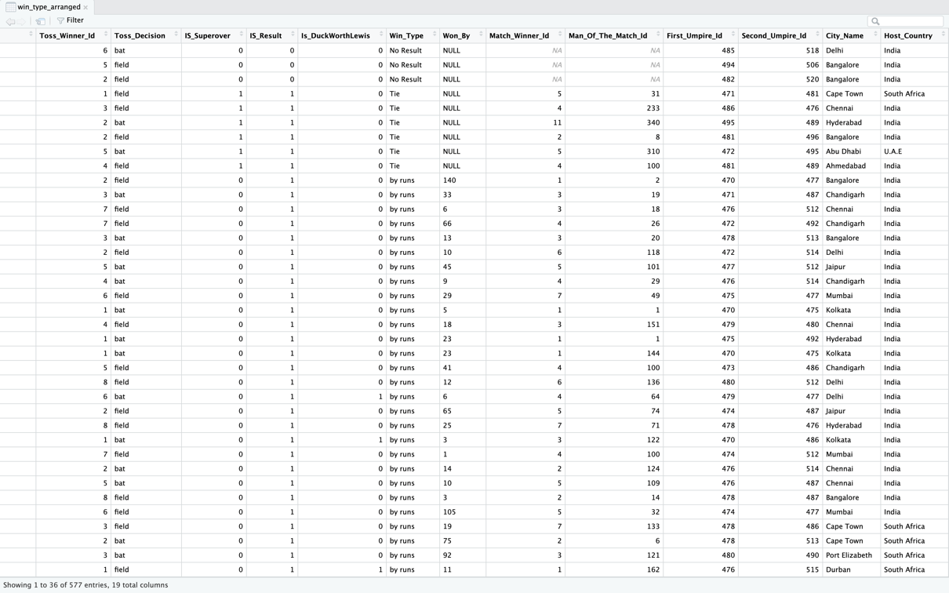

Code:

city_name_arranged = data %>% arrange(City_Name)

View(city_name_arranged)

Output:

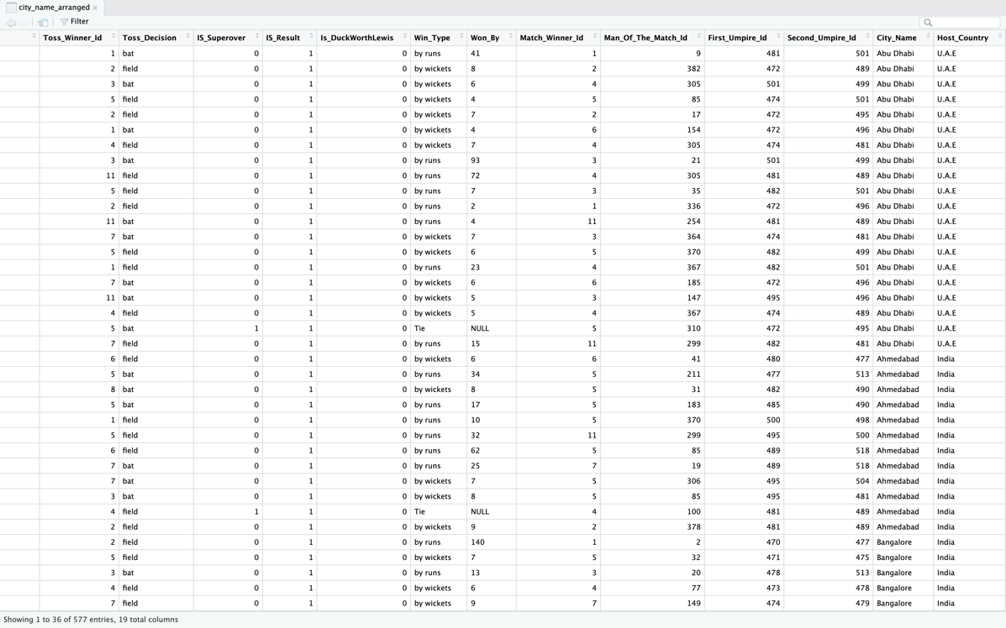

Code:

match_dates = data %>% select(Match_Date)

View(match_dates)

Output:

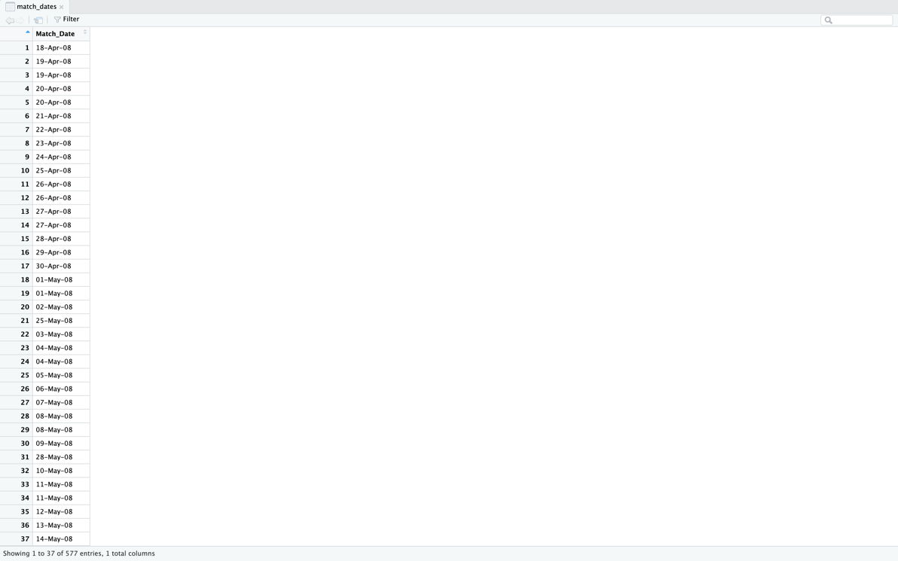

Code:

city_and_country = data %>% select(City_Name, Host_Country)

View(city_and_country)

Output:

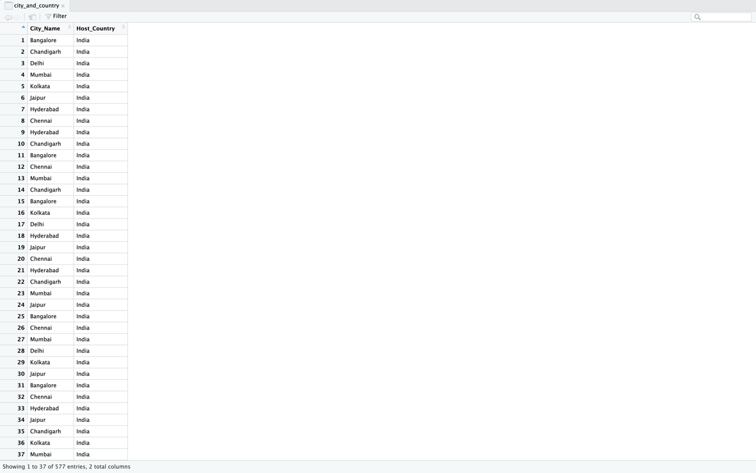

Code:

all_but_match_id = data %>% select(-Match_Id)

View(all_but_match_id)

Output:

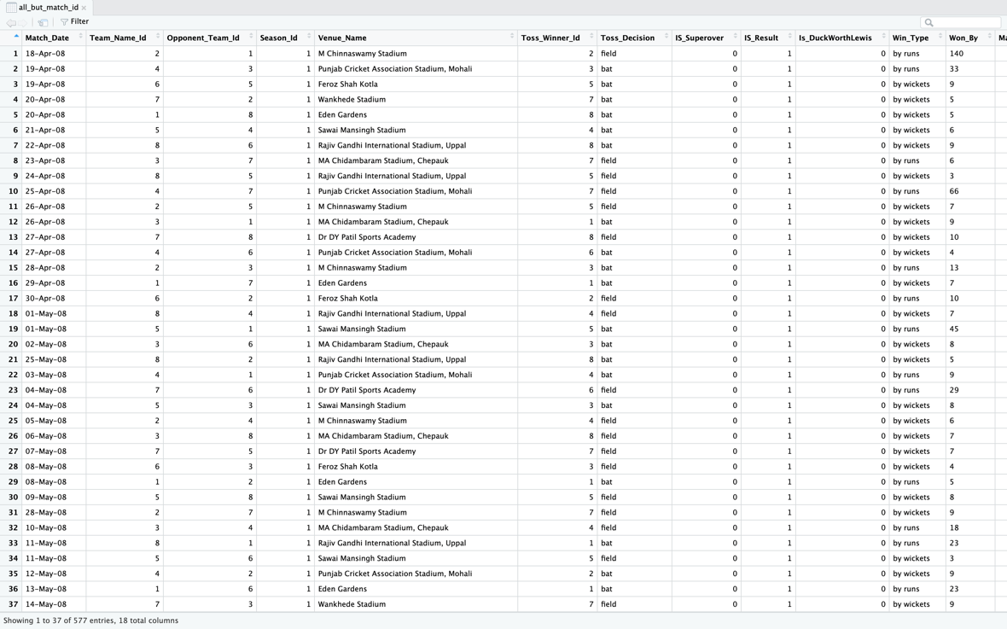

Code:

bangalore_matches = data %>% filter(City_Name == "Bangalore")

View(bangalore_matches)

Output:

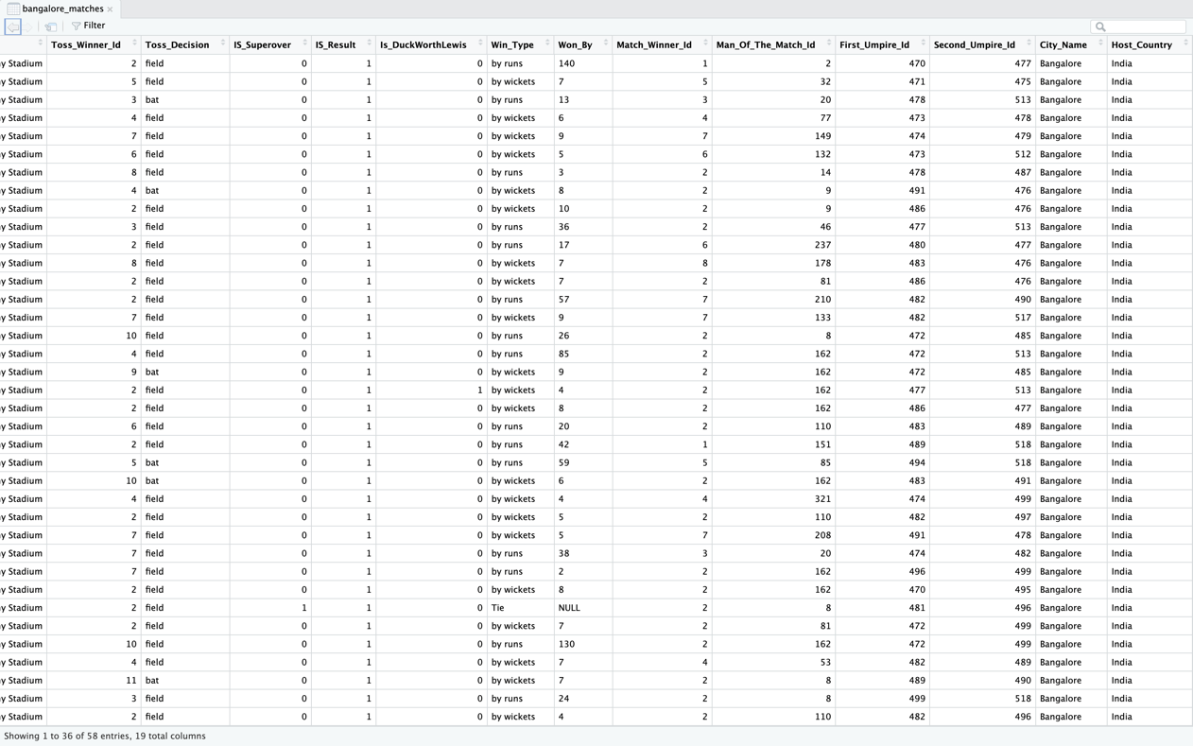

Code:

no_result_matches = data %>% filter(Win_Type == "No Result")

View(no_result_matches)

Output:

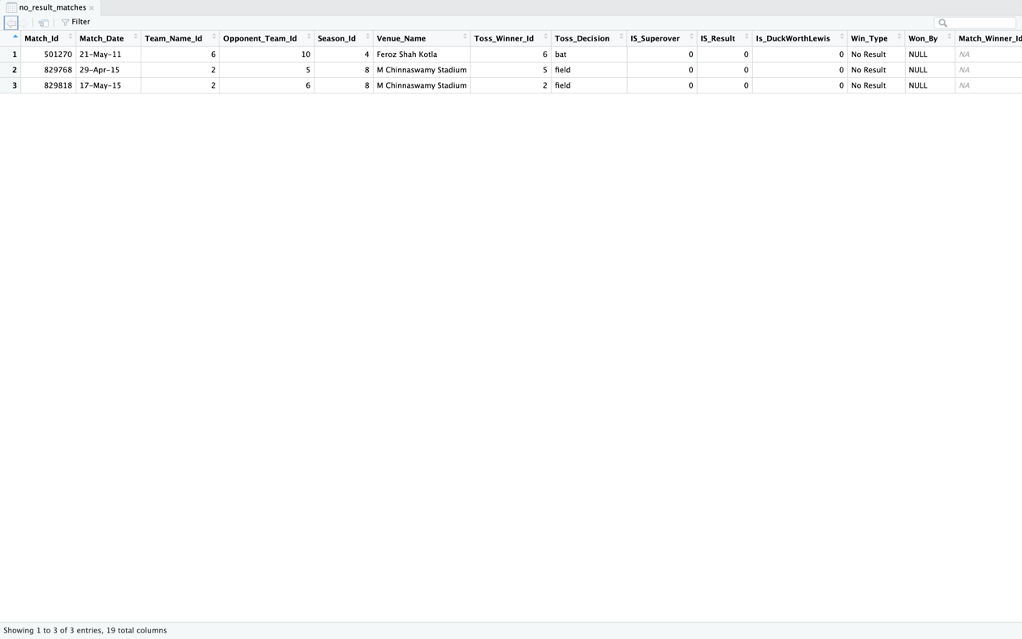

Code:

india_bat_matches = data %>% filter(Host_Country == "India", Toss_Decision == "bat")

View(india_bat_matches)

Output:

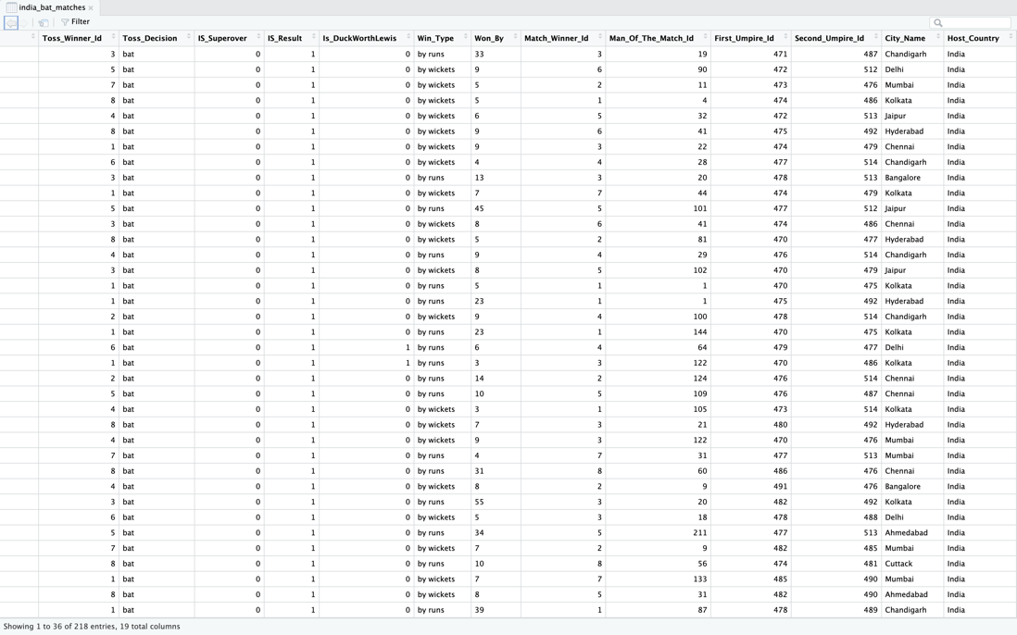

Code:

custom_data = data.frame(

Name = c("Abhinav", "Tanush", "Sumathi"),

English = c(45, 67, 87),

Math = c(53, 65, 23)

)

gathered = custom_data %>% gather("Course", "Marks", 2:3)

View(gathered)

Output:

Code:

spread = gathered %>% spread("Course", "Marks")

View(spread)

Output:

Code:

grouped = data %>% group_by(Host_Country) %>%

summarise(count = n())

View(grouped)

Output:

Code:

mutated = data %>% mutate(year=format(as.Date(data$Match_Date, format="%d-%b-%y"), "%Y"))

View(mutated)

Output:

